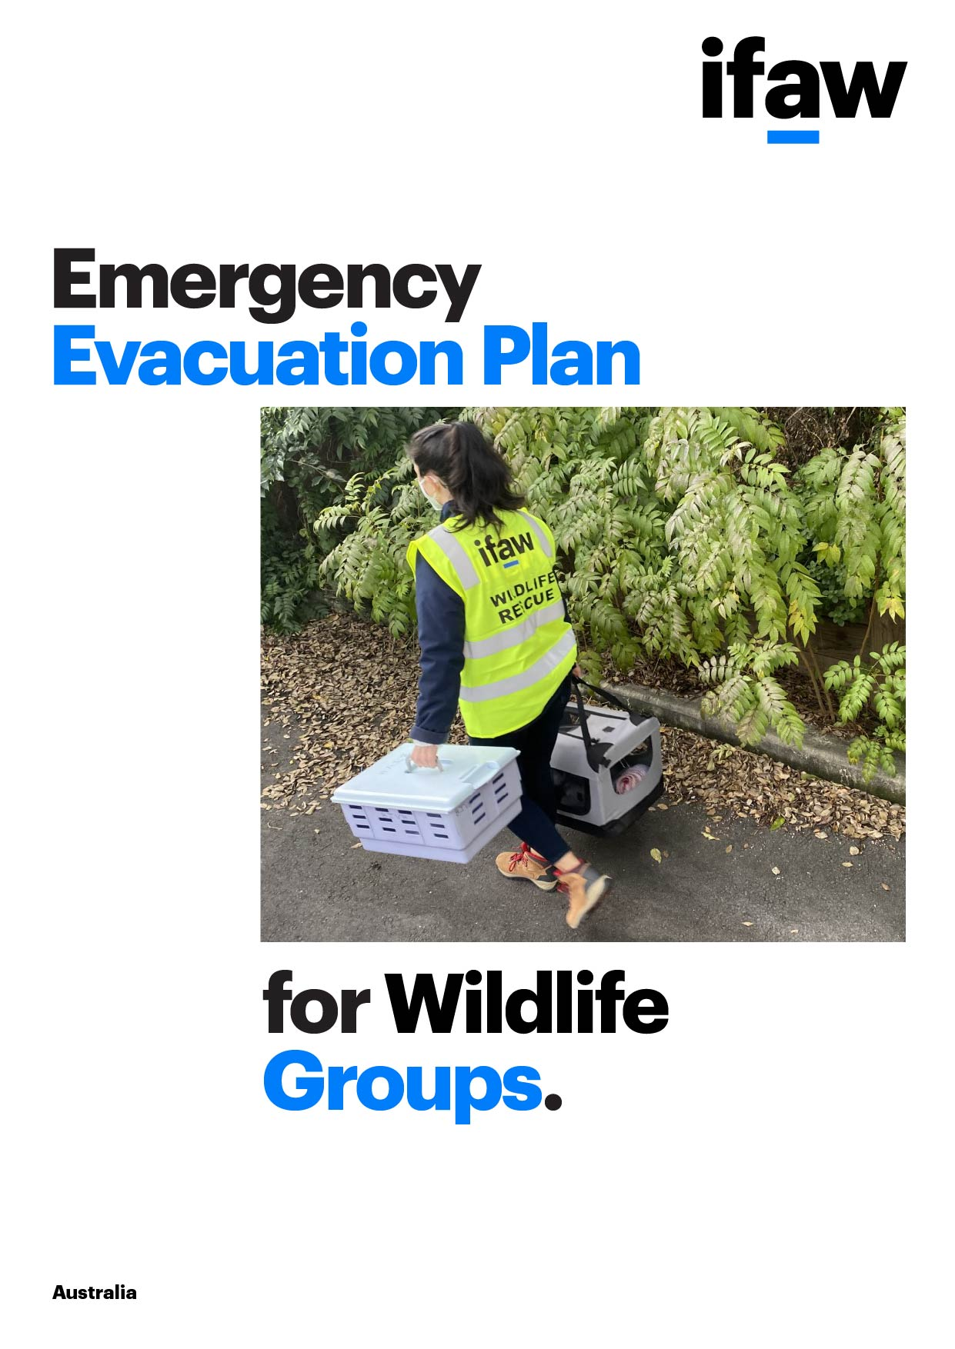

Background
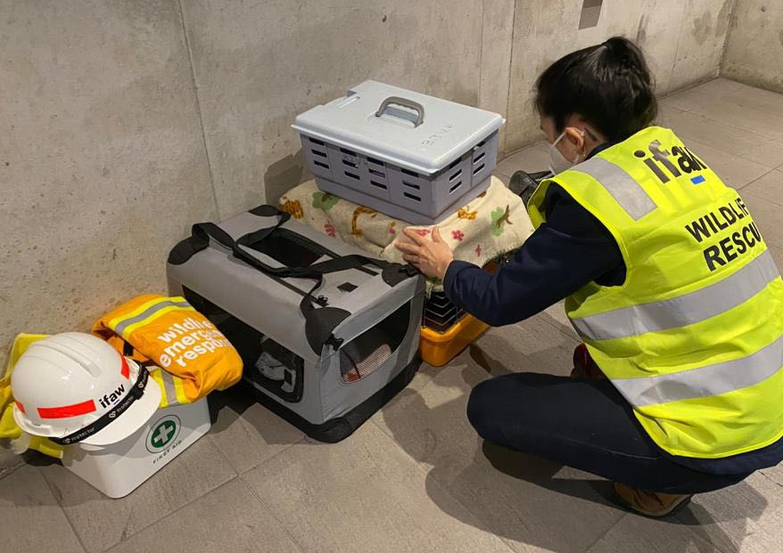
Disasters around the world are increasing in frequency and magnitude, threatening our work to rescue and care for animals in need. Now is the time to prepare.
This evacuation plan template has been designed to assist wildlife rehabilitation groups to evacuate animals and occupants of the facility in the event of a disaster or other emergency. Activation of the plan should be at the direction of Emergency Services. We hope that you never have to evacuate your facility, but if you need to, this plan will help guide the process.
An evacuation plan is only one part of an Emergency Management Plan, which will ensure your organization is prepared to manage operations when faced with a variety of risks. We recommend every wildlife rehabilitation group continue to prepare for future emergencies by developing an Emergency Management Plan.
This template was designed by the International Fund for Animal Welfare and developed in collaboration with local wildlife rehabilitation professionals, including those experienced in evacuating their facility. We are grateful for the sharing of lessons learned to help make this a useful, practical tool.
For more information on how to develop this plan, please refer to the Emergency Evacuation Guidelines or contact Jennifer Gardner at jgardner@ifaw.org or Nicole Rojas Marin at nmarin@ifaw.org.

Disclaimer: These materials are intended to assist wildlife rehabilitation groups and individual wildlife carers. While we attempt to address specific topics, it is not possible to include everything necessary. Thus, this information must be understood as a tool rather than a complete presentation of all problems and issues regarding disaster management. It is also generic and may not be accurate for all circumstances. IFAW expressly disclaims responsibility, and shall have no liability for any damages, loss or injury whatsoever suffered as a result of your reliance on the information contained in these materials.

Replace this text with group logo

Emergency Evacuation Plan for
Insert Group Name

Emergency Evacuation Plan

Name of the facility:
Address…………………………………………………………
……………………………………………………………………
……………………………………………………………………

Primary contact person:
Position / role........................................................................
Phone number......................................................................
Mobile number......................................................................

Secondary contact person:
Position / role........................................................................
Phone number......................................................................
Mobile number......................................................................

Number of buildings...............................................................
Average number of personnel on-site....................................
Average number of animals on-site.......................................

Prepared by: Date:
Date last updated……………………………………………….
Date of staff and volunteer review…………………………….

Step 1. Identify Emergency Support Network

Emergency Response Team

The following leadership roles support disaster planning and lead implementation during emergencies.
Role* | Responsibilities | Primary Person | Back-up Person
Incident Lead | Insert Text | Insert Text | Insert Text
Communications Lead
Logistics Lead
*Suggested roles

Emergency Contacts

List contact details such as website, phone number, and/or email of the nearest emergency services and wildlife establishments that could provide support during an emergency.
Local Agency | Contact Information
Rural Fire Service (RFS) | Insert Text
Police Force
Hospital
Government Council
Veterinary Hospital
Wildlife Zoo/Sanctuary

Temporary Placement
List of facilities or carers with the capacity and skills to take in evacuated animals during an event.
Name | Phone Number/ Email | Address | Holding Capacity | Estimated Traveling Time | Confirmed Date
Insert Text | Insert Text | Insert Text | Insert Text | Insert Text | Insert Text

Step 2. Animal Management

Animal List
List of animals in care at the beginning of each disaster season or beginning of an emergency event.
Species | Total Number | Name/ID# | Medical/behavior priority | Temporary facility/carer
Insert Text | Insert Text | Insert Text | Insert Text | Insert Text
Brief description of each category and estimated packing time
Category 1
Category 2
Category 3
Step 3. Resources

Roles and Responsibilities

Common roles in a disaster event such as a driver, veterinarian, animal handler, supplies coordinator, outreach/comms or admin support. Consider assigning back up people for essential roles.
Role | Responsibilities | Primary Person | Confirmed
Insert Text | Insert Text | Insert Text | ☒
 |  |  | ☐
 |  |  | ☐
 |  |  | ☐
 |  |  | ☐
 |  |  | ☐
 |  |  | ☐
 |  |  | ☐
 |  |  | ☐
 |  |  | ☐
 |  |  | ☐
 |  |  | ☐
 |  |  | ☒
 |  |  | ☐
 |  |  | ☐
 |  |  | ☐
 |  |  | ☐
 |  |  | ☐
 |  |  | ☐
 |  |  | ☐

Supplies and Equipment

Common supplies and equipment needed to evacuate and provide continuity of care of animals such as carriers, medications, and food. Consider specialised materials that may be needed to capture and sedate animals.
Type | Quantity  Needed | Quantity Available | Source of missing items | Acquired
Insert Text | Insert Text | Insert Text | Insert Text | ☒
 |  |  |  | ☒
 |  |  |  | ☐
 |  |  |  | ☐
 |  |  |  | ☐
 |  |  |  | ☐
 |  |  |  | ☐
 |  |  |  | ☐
 |  |  |  | ☐
 |  |  |  | ☐
 |  |  |  | ☐
 |  |  |  | ☐
 |  |  |  | ☐
 |  |  |  | ☐
 |  |  |  | ☐
 |  |  |  | ☐
 |  |  |  | ☐

Transportation

Vehicles needed to transport the animals to safety. Ensure vehicles are ready to go by filling with petrol in advance of the evacuation.
Type | Animal capacity | Location / point of contact
Insert Text | Insert Text | Insert Text

Step 4. General Evacuation Planning

Site Layout

Include a site layout identifying key areas during an evacuation or an emergency such as emergency exits, transport pickup sites, animal enclosures, supplies storage and the emergency assembly area within the property.

Evacuation Routes Map

Include a map of your area, highlighting main and alternate evacuation routes.

Other Important Items to Remove

Consider additional items you need to pack and take with you during an emergency such as personal items and electronics.
Description | Location | Checklist
Insert Text | Insert Text | ☒
 |  | ☐
 |  | ☐
 |  | ☐
 |  | ☐
 |  | ☒

Last Walk-Through

Use the checklist below to perform last walk-though to ensure key actions are complete before leaving the premises during an evacuation.

 | Yes | No
Keys are secure and accounted for | ☒ | ☐
Safes/locked cupboard are secured | ☐ | ☐
Doors and windows that closed and locked | ☐ | ☐
Power switches turned off | ☐ | ☐
Surveillance equipment is operating | ☐ | ☐
Alarms are armed or disarmed as required | ☐ | ☐
Heating, Ventilating, and Air Conditioning Equipment on/off as required | ☐ | ☐
Refrigerators and freezers are unplugged/plugged as required | ☐ | ☐
Small appliances are unplugged/plugged | ☐ | ☐
Fire extinguishers are updated and operable | ☒ | ☐
Smoke and/or heat detectors are operable | ☐ | ☐
Water points are operable (and signaled) | ☐ | ☐
Sprinkler system is operable | ☐ | ☐
Halon or other fire suppression system is operable | ☐ | ☐
Fire alarms are operable | ☐ | ☐
Back-up systems have been checked | ☐ | ☐
Copy of Admin docs in USB secured | ☐ | ☐
All personnel are off the premises | ☒ | ☐
All animals have been evacuated | ☐ | ☐
 | ☐ | ☐
 | ☐ | ☐
 | ☐ | ☐
 | ☐ | ☐
 | ☐ | ☐
*Suggested actions

Re-Entry Walk-Through

Use the checklist below to perform a re-entry walk-through to ensure the facility is secure and operational for animals to return.
Description* | Yes | No
Water, operational and potable | ☐ | ☐
Power | ☐ | ☐
Structures are sound | ☐ | ☐
Animal enclosures are secure and functional | ☐ | ☐
Appliances are operable | ☐ | ☐
Animal food is viable | ☐ | ☐
Animal medications are viable | ☐ | ☐
 | ☐ | ☐
 | ☐ | ☐
 | ☐ | ☐
 | ☐ | ☐
 | ☐ | ☐
 | ☐ | ☐
*Suggested resources required

Step 5. Action Plan

Action Statements
Procedures for evacuation in the event of an extreme weather event. Delegate roles and responsibilities as outlined in Step 1.
Trigger | Action
Extreme weather  season starts  Bushfire, flood,  cyclone, drought |  | Monitor local weather services (ie BOM, RFS) for local conditions.  Based on your Evacuation plan and current number of animals in care, check availability of:  ☐ Personnel - make sure contact information is up to date  ☐ Temporary placement facilities or carers  ☐ Equipment and supplies  ☐ Transportation  Notes:
Advice alert  is issued  A weather event has  started, there is no  immediate danger |  | Monitor local weather and Emergency Services (ie BOM, RFS) for updates.  Prepare for evacuation  ☐ Personnel: Activate Emergency Response Team. Share plan with personnel. Consider hazards and possible health and safety issues when assigning responsibilities.  ☐ Placement: Identify and confirm availability of temporary placement facilities or carers.  ☐ Animals: Update animal list and categories. Calculate average packing time. Prepare animal ID cards.  ☐ Equipment and supplies: Stage carriers with basic supplies. Ensure adequate supplies such as food and medications are available for the number of animals currently in care.  ☐ Transportation: Check transport resource availability and make sure fuel tank is full.  Reach out to your Emergency Support Network to help fulfill any identified unmet needs.  Report preparation status to appropriate Local Emergency Service agency.  Notes:
Watch and act  alert is issued  A weather event is in the surrounding area. There is a heightened level of threat.  You need to start taking  action now to protect  yourself and the animals. |  | Consult available, real-time Emergency Service resources to set evacuation decision-making criteria and timeline.  Activate evacuation plan  ☐ Coordinate with Emergency Response Team to confirm the plan and timeline for the evacuation.  ☐ Alert personnel and temporary placement facilities or carers of the plan and timeline.  ☐ Update website and social media of the facility status.  ☐ Evacuate animals according to categories. Ensure proper paperwork, including ID cards, and supplies accompany each animal.  ☐ Perform last walk-through.  Maintain communication with Emergency Response Team, personnel and Emergency Services to provide updates on the status of the emergency event and the evacuation.  Notes:
Emergency  warning  This is the highest level of alert. You are in imminent danger. |  | Monitor local weather and Emergency Services (ie BOM, RFS) for updates.  Take action to survive  ☐ Team members who have not left yet must leave immediately to a safer place if possible.  ☐ If they are unable to leave, they need to get ready to take shelter in the facility.  ☐ If there are animals left on the premises that were unable to be evacuated, open the gates or drop fences to allow them to escape.  Notes:
All clear  Issued when the threat has passed. |  | After consultation and direction from Emergency Services, perform a re-entry walk-through to ensure the facility is secure and operational. If the facility is damaged, arrange longer-term placements with back-up facilities or carers.  Initiate re-entry  ☐ Communicate with personnel and temporary placement facilities and carers of the return plan and timeline  ☐ Check paperwork to confirm animal ID before returning to enclosure.  ☐ Perform animal health assessments.  ☐ Share update on website and social media.  Notes:

Documents to be attached to this plan:
☐ Personnel Contact List
☐ MOUs/Agreements with Temporary Placement Facilities
☐ Site Layout of Premises
☐ Evacuation Routes Map
☐ Copy of Rescue and Rehab permit or license

Appendix

Personnel Contact List
Use this table for personnel details. Update at the beginning of each disaster season or yearly at a minimum.
Name | Role | Phone Number/ Email | Health priority? Yes/No | Emergency contact name and number
Insert Text | Insert Text | Insert Text | Insert Text | Insert Text
Transport Manifest
Use the tables below to list animals transported from your site to the temporary placement
Driver’s name…………………………………….. Number plate………………………………………….
Date of Transport………………………………… Time of Departure…………………………………….
Point of Origin……………………………………. Time of Arrival………………………………………...
Destination……………………………………….. Time finished unloading……………………………..
Intake number | Name/ID number(s) | Species | Comments
Insert Text | Insert Text | Insert Text | Insert Text

--------------------------------------------------------------------------------------------------------------------------
Driver’s name…………………………………….. Number plate………………………………………….
Date of Transport………………………………… Time of Departure…………………………………….
Point of Origin……………………………………. Time of Arrival………………………………………...
Destination……………………………………….. Time finished unloading……………………………..
Intake number | Name/ID | Species | Comments
Insert Text | Insert Text | Insert Text | Insert Text

ID Card - For identification purposes, clip or tape to the animal carrier once ready to evacuate. Waterproof if possible.
---------------------------------------------------------------------------------------------------------------------------
ID Card

Originating Carer: ____________________________ Phone: ___________________

Temporary Placement: ________________________ Phone: ___________________

Animal ID#: ____________ Species: ____________

Photo of Animal:

-----------------------------------------------------------------------------------------------------------------------

Care card - Include this care card in the animal's Evacuation Kit to provide the carer with clear instructions on how to care for this animal.

Care Card

NAME __________________________AGE _________SPECIES ________________________________

ID _____________________________ORIGINATING CARER __________________________________

Pre-existent conditions

☐ Enclosure needs:

☐ Diet needs:

TYPE_______________________QUANTITY_________________FREQUENCY____________________
Preparation instructions:
☐ Medications

TREATMENT ________________DOSAGE___________________FREQUENCY____________________

TREATMENT ________________DOSAGE __________________FREQUENCY ____________________

